OOP Project Report
Project Title: Space Trader: Retro 2D Space Trader GAme
Group Members: Burhan uddin 24k-3056
hassan 24k-3098
Submission Date: 27 November 2025
1. Executive Summary
Overview: The Space Trader project is a retro-style 2D game developed in C++ using the SFML 3 framework. The game simulates space navigation, resource trading between planets (Earth and Mars), and survival against random asteroid hazards and pirate attacks. Core mechanics include real-time player movement, dynamic trading menus, upgradeable ship attributes, event handling (asteroids, pirate raids), scoring and high-score persistence.
Key Findings:
- Implemented a modular class hierarchy leveraging OOP concepts: inheritance (ShipUpgrade, Event), composition (Game contains Planets, Asteroids), and polymorphism (apply upgrades, trigger events).
- Achieved stable 60 FPS rendering with efficient update and draw cycles.
- Enabled persistent high-scores via file I/O, with a robust save-and-delete mechanism for session data.
2. Introduction
Background: Object-Oriented Programming (OOP) principles underpin modern game development, promoting maintainability, reusability, and clear abstraction. This project demonstrates OOP by modeling game entities (Spaceship, Planet, Asteroid) as classes with well-defined interfaces, showcasing inheritance, encapsulation, and polymorphism.
Project Objectives:
- Develop a functional 2D space trading game using C++ and SFML.
- Demonstrate OOP design patterns through a modular class hierarchy.
- Incorporate dynamic gameplay elements: trading, upgrades, random events, and scoring.
- Ensure asset management (textures, audio) and user input handling are robust and efficient.
3. Project Description
Scope: Included:
- Player-controlled spaceship with movement, shooting placeholder.
- Two planet nodes (Earth, Mars) offering trade of three commodities.
- Upgrade system for shields, engine speed, and cargo capacity.
- Random asteroid generation and wrap-around movement.
- Pirate attack events deducting player credits.
- Persistent high-score system using text file storage.
Excluded:
- Multiplayer functionality.
- Advanced AI behaviors or enemy ships beyond simple events.
- Networking or online leaderboards.
Technical Overview:
- Language: C++17
- Framework: SFML 3 (Graphics, Audio)
- Build Tools: Visual Studio / CMake
- Key Libraries: <random> for stochastic events, <fstream> for file I/O, STL containers (std::map, std::vector) for game state management.
4. Methodology
Approach: The development followed an iterative weekly plan:
- Week 1: Project setup, SFML integration, window and rendering loop.
- Week 2: Implement Spacesement, player input handling, audio feedback.
- Week 3: Design Planet trading system with menus and dynamic pricing.
- Week 4: Develop Asteroid class, collision detection, and wrap-around logic.
- Week 5: Integrate ShipUpgrade and Event systems using polymorphism.
- Week 6: Scoring, high-score persistence, and game over logic.
- Week 7: Testing, debugging, and optimization.
Roles and Responsibilities:
- Member 1: Core gameplay loop, rendering, asset pipeline, and Collision detection.
- Member 2: Trading mechanics, upgrade/event systems, file I/O for scores, random event logic, testing & documentation.
5. Project Implementation
Design and Structure:
- Game class orchestrates the main loop, event handling, updates, and rendering.
- Spaceship encapsulates player state (health, shield, credits, cargo, upgrades).
- Planet manages trading menus, pricing algorithms based on reputation.
- Asteroid handles movement, rotation, collision, and damage values.
- ShipUpgrade (abstract) and derived classes (ShieldUpgrade, EngineUpgrade, CargoUpgrade) apply enhancements via polymorphism.
- Event (abstract) with PirateAttack and SolarFlare to simulate dynamic hazards.
Functionalities Developed:
- Real-time input-driven movement with sound feedback.
- Dynamic on-screen menus for trading (keys 1–6), upgrades (U menu), and resources (R menu).
- Procedural asteroid field with size-based speed and damage, screen wrap-around.
- Reputation-influenced pricing adjustments and supply tracking per planet.
- Persistent high-score list stored in scores.txt and displayable via in-game UI.
Challenges Faced:
- Asset Loading Failures: Ensured robust error handling for missing textures/sounds.
- Collision Precision: Tuned sprite origins and bounds checking for accurate asteroid-ship interactions.
- Data Persistence: Managed file I/O to append and delete score data securely upon game exit.
- Menu State Management: Resolved state toggling conflicts between trading, upgrade, and resource menus.
6. Results
Project Outcomes:
- Delivered a playable SFML-based space trading game demonstrating key OOP concepts.
- Achieved responsive controls and a cohesive UI for trading and upgrades.
- Maintained stable performance across multiple game sessions.
Screenshots and Illustrations:
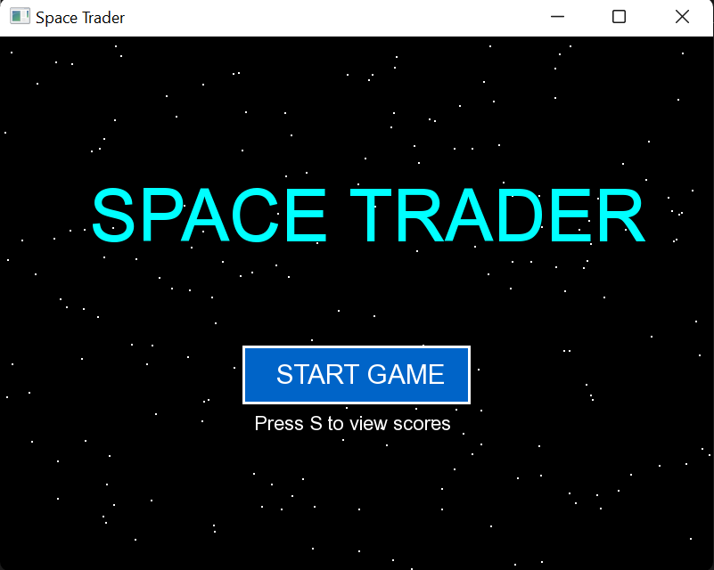
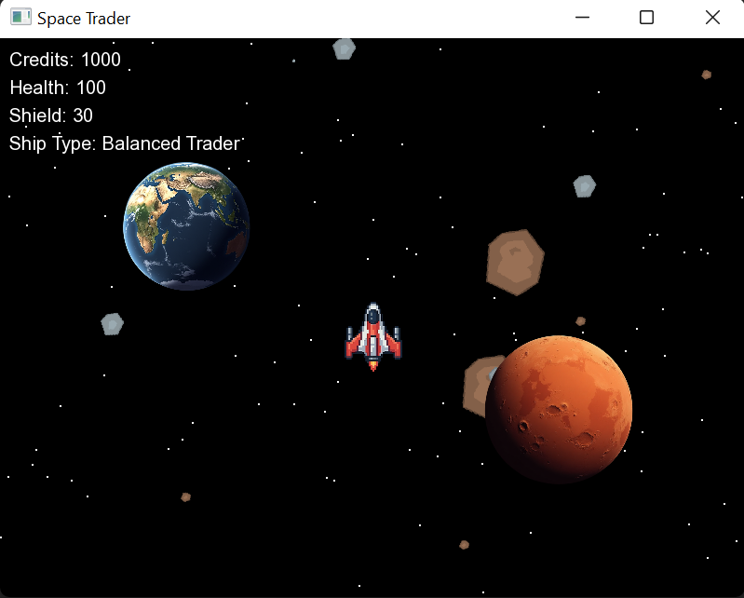
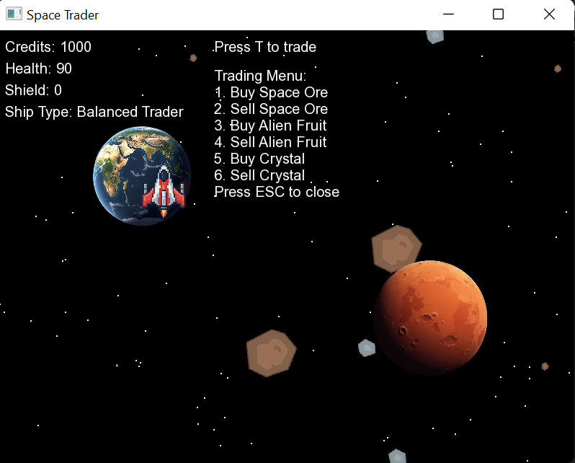
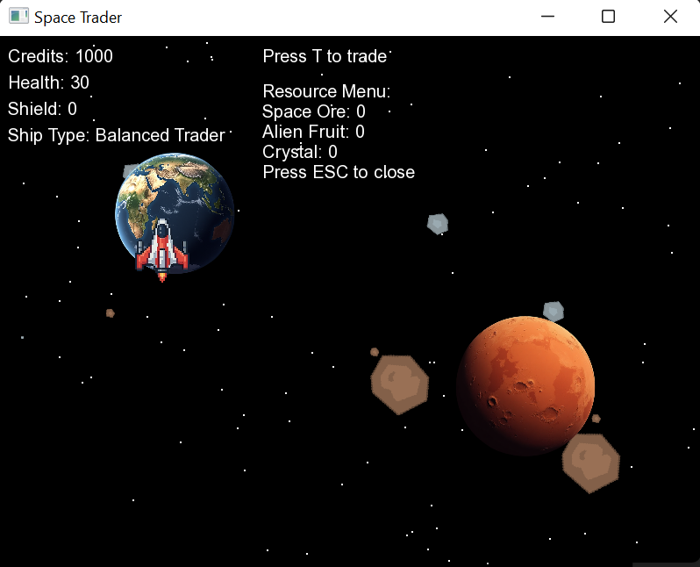
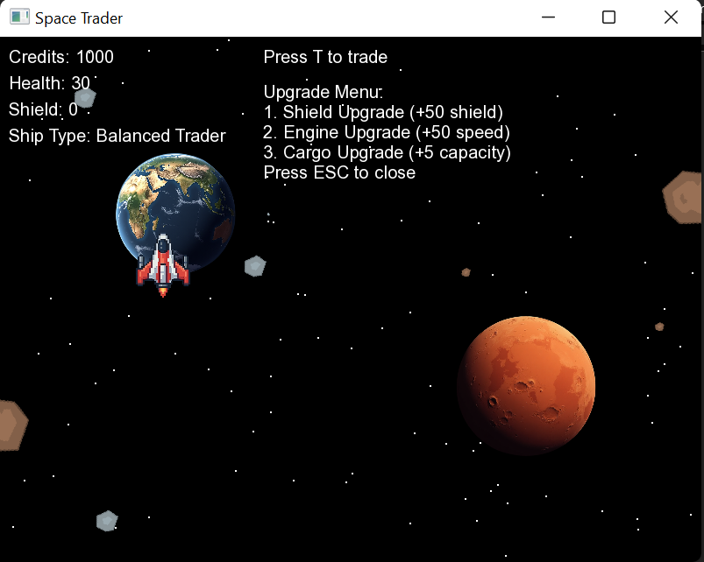
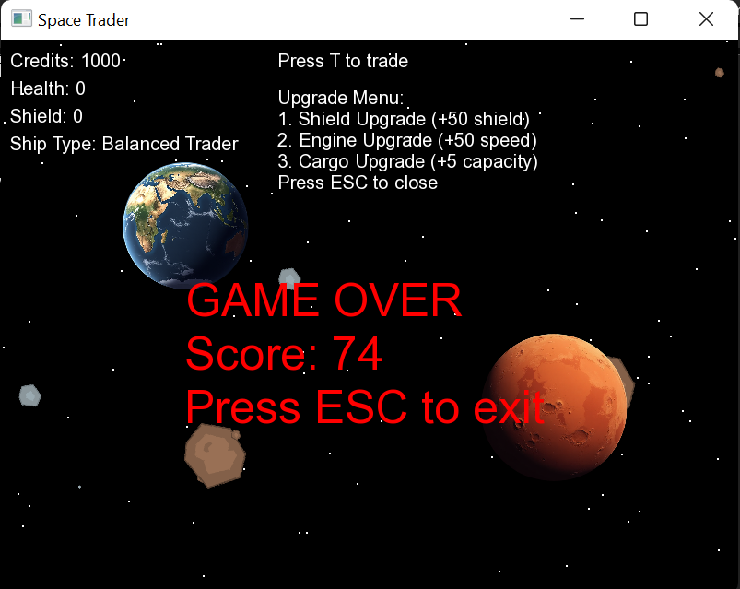
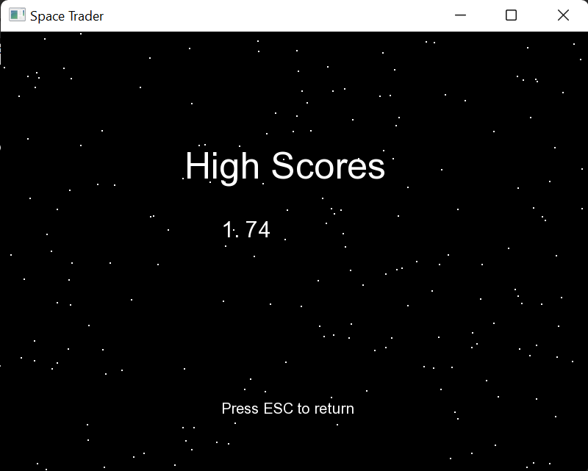
Testing and Validation:
- Functional Testing: Verified each menu operation (trade, upgrade, resource) via manual playthrough.
- Edge Cases: Tested asteroid wrap-around at screen boundaries and large asteroid collisions triggering game over.
- Performance: Maintained 60 FPS cap under heavy asteroid count using setFramerateLimit(60).
- Persistence: Confirmed high-score entries are correctly saved, displayed, and cleared on exit.
7.Conclusion
Summary of Findings: The Space Trader project successfully demonstrates the application of OOP principles in game development. Core features including movement, trading, upgrades, event-driven hazards, and score persistence operate reliably and cohesively.
Final Remarks: Future enhancements could include additional event types (SolarFlares with gameplay impact), AI-driven pirate ships, networking for online leaderboards, and expanded planetary systems. Overall, this project forms a solid foundation for more advanced SFML-based games.

